JECRC
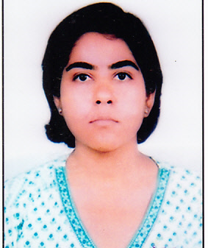
JAIPUR

INDIVIDUAL FACULTY DATA SHEET
Name of the faculty member | : | Shruti Kalra
Present Designation | : | ASSOCIATE PROFESSOR
Email Id: shrutikalra.ece@jecrc.ac.in, shrutisumitkalra@gmail.com
Contact Details: 91-9414371413

I. Particulars of Educational Qualification: (only completed)

Category | Name of the Degree | Specialization | Year of Passing | Name of the College | Name of the University
UG | B.E | Electronics & Communication | 2003 | MITS | University of Rajasthan
PG | M. Tech | VLSI Design | 2009 | MNIT, Jaipur | NIT, Jaipur
Ph.D. |  | Photonics & Optical Communication | Pursuing | MNIT, Jaipur | NIT, Jaipur

II. Academic Experience : 15 Years

III. Industrial Experience : NA

IV. Title of Ph.D. Thesis : NA

V. Awards/Achievements :

VI. Research/Specialization : Optical Communication, Photonics

VII. Course Taught : Digital Electronics, VHDL, Optical fiber Communication, Linear Integrated Circuits, IC Technology, MEMS and Nano Technology

VIII. Refereed International Journal Publication : 01

IX. International Conference Proceeding : 06

X. Books Written : NA

XI. M.Tech Thesis Guide : Dr. Ghanshyam Singh

XII. PHD Thesis Guide : Dr. Ghanshyam Singh

XIII. Professional Body Membership : IEEE

